**Answer to the Question No. 3(PART-II)**

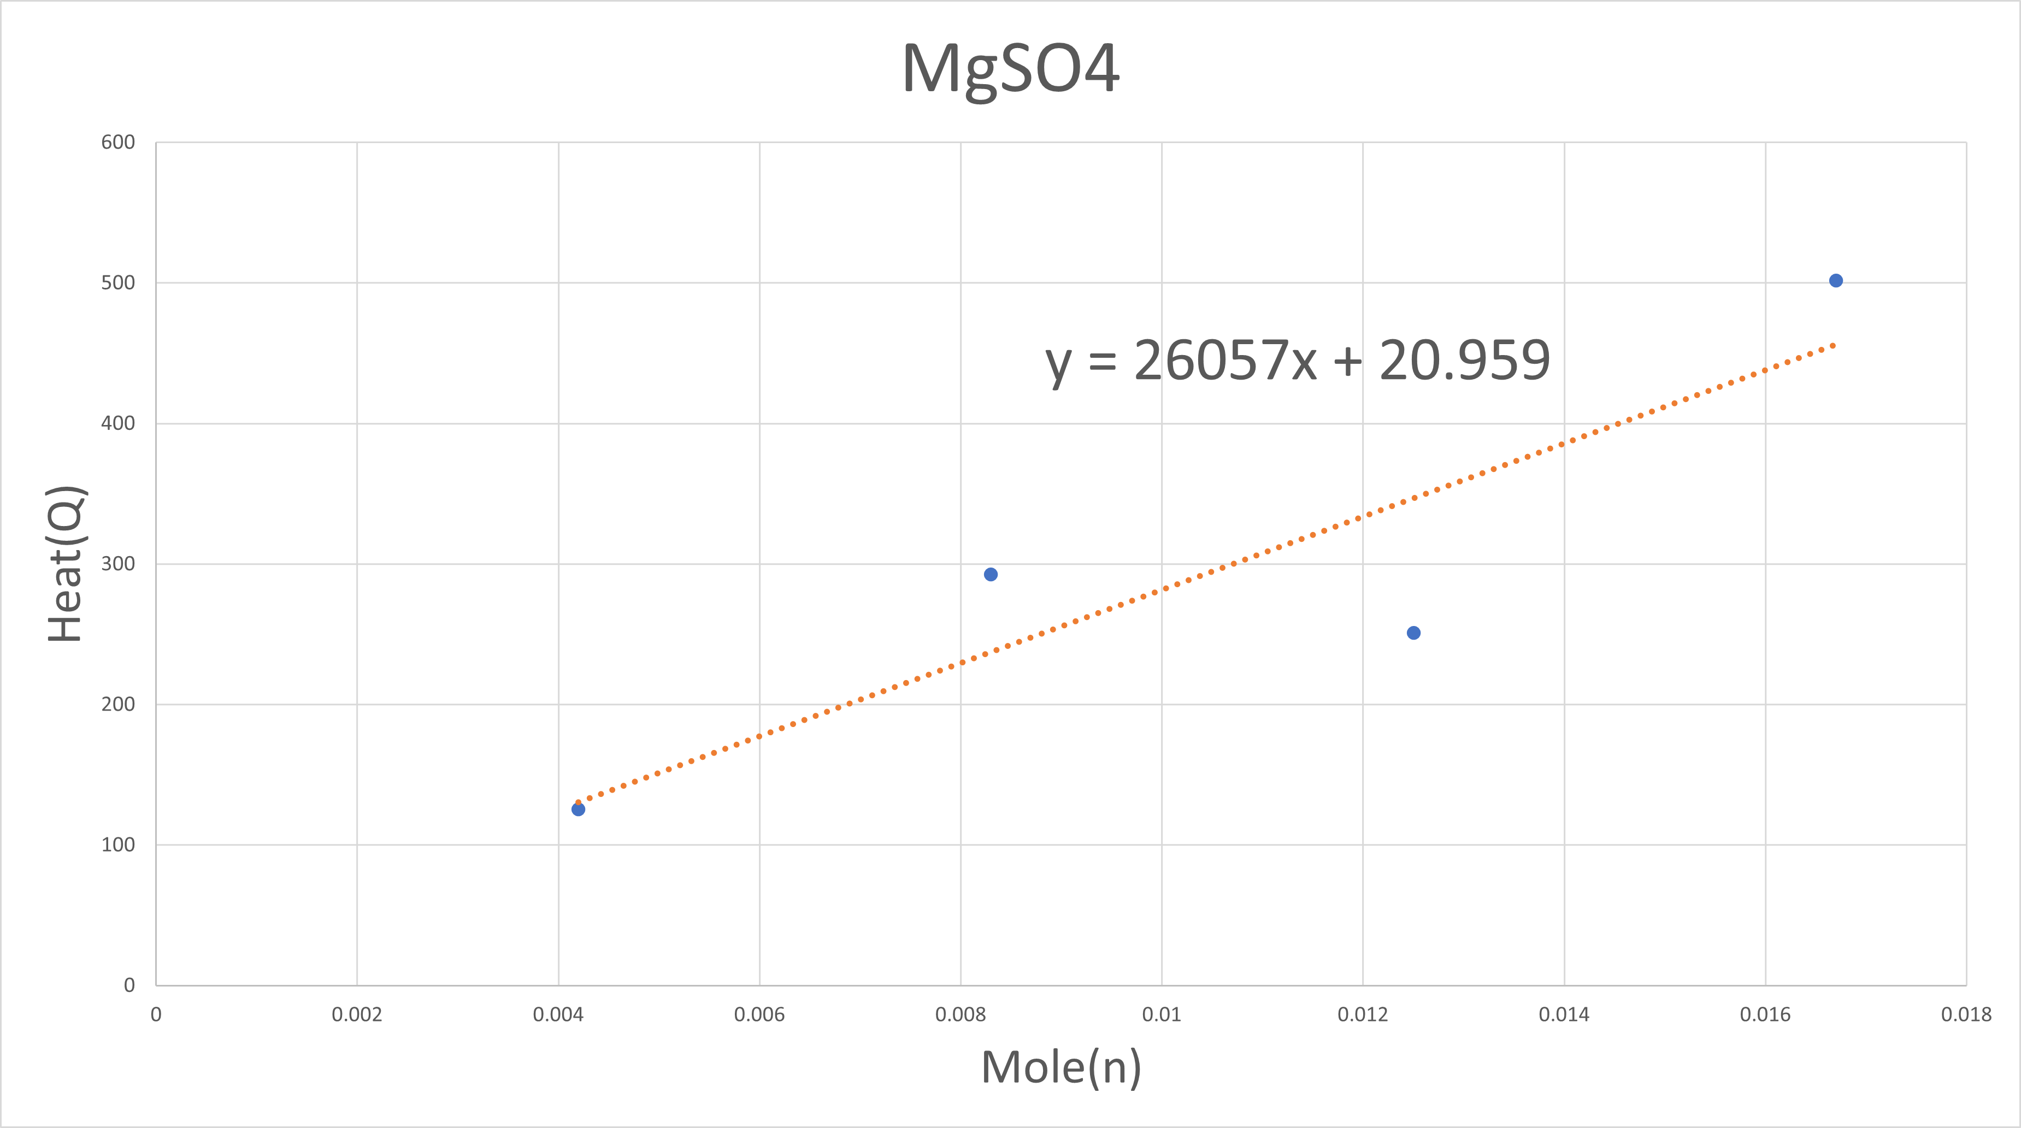

**Equation: y = 26057x + 20.959, comparing y=mx+c then slope = 26057**

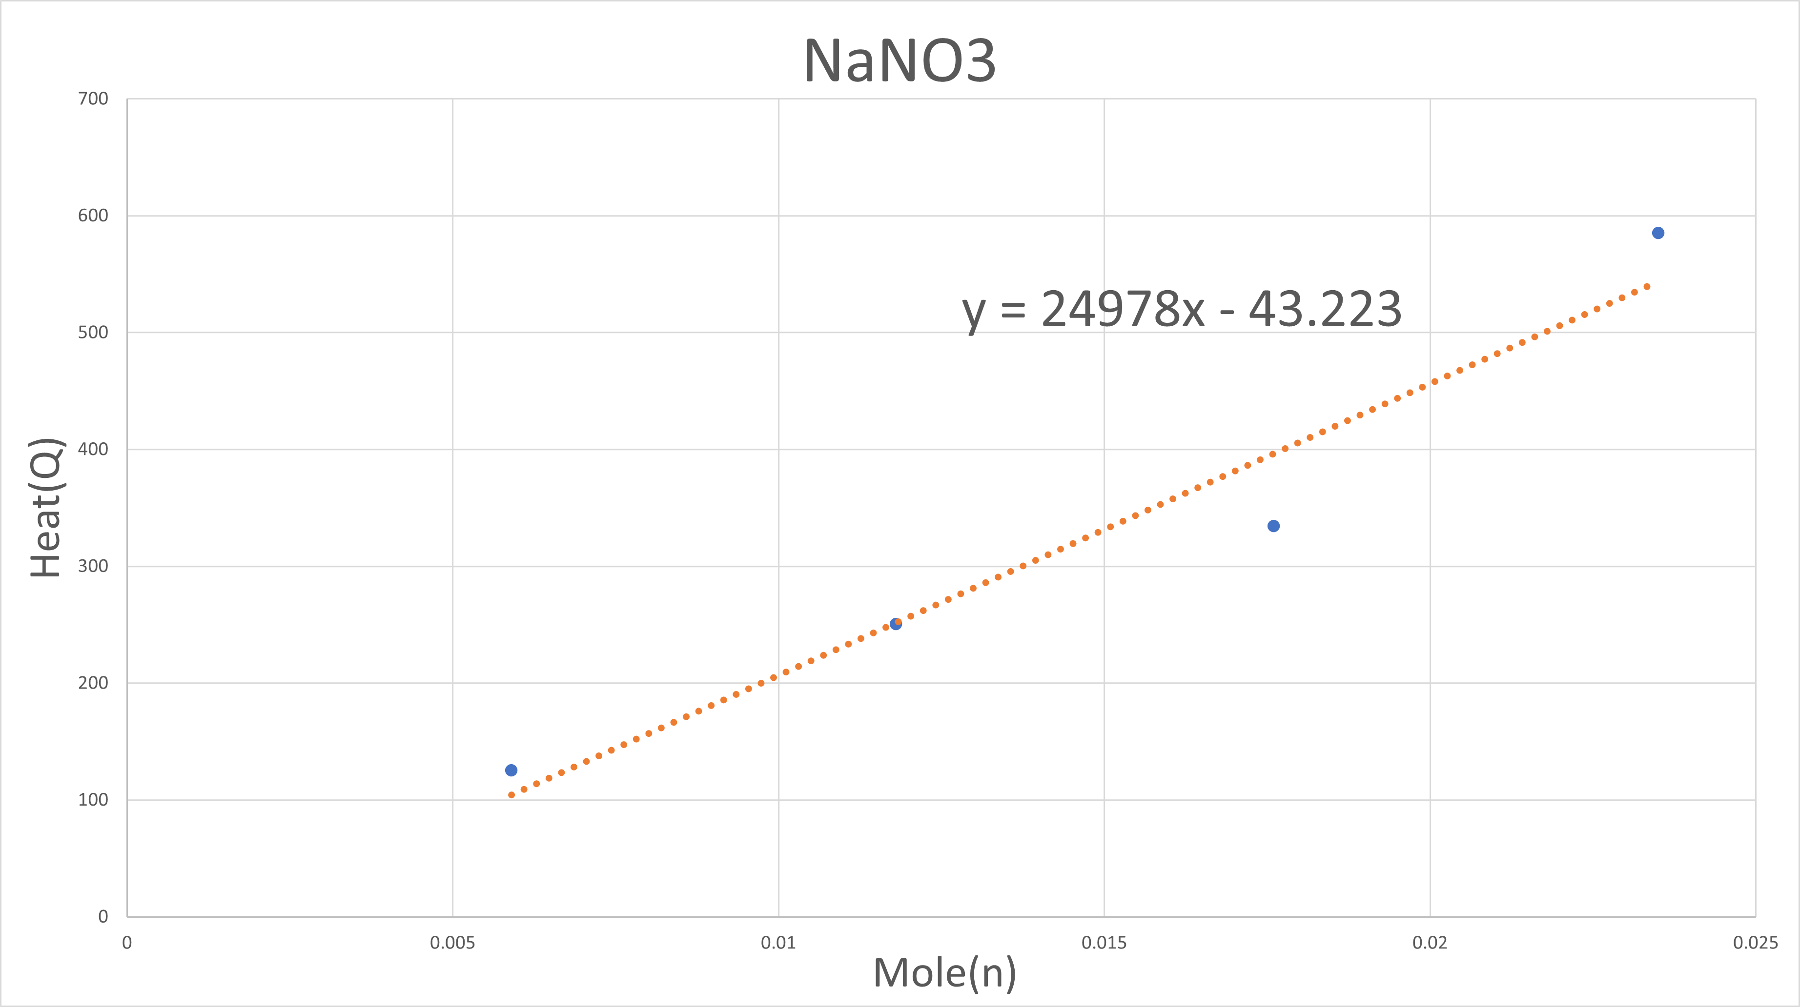

**Equation: y = 24978x - 43.223, comparing y=mx+c then slope = 24978**